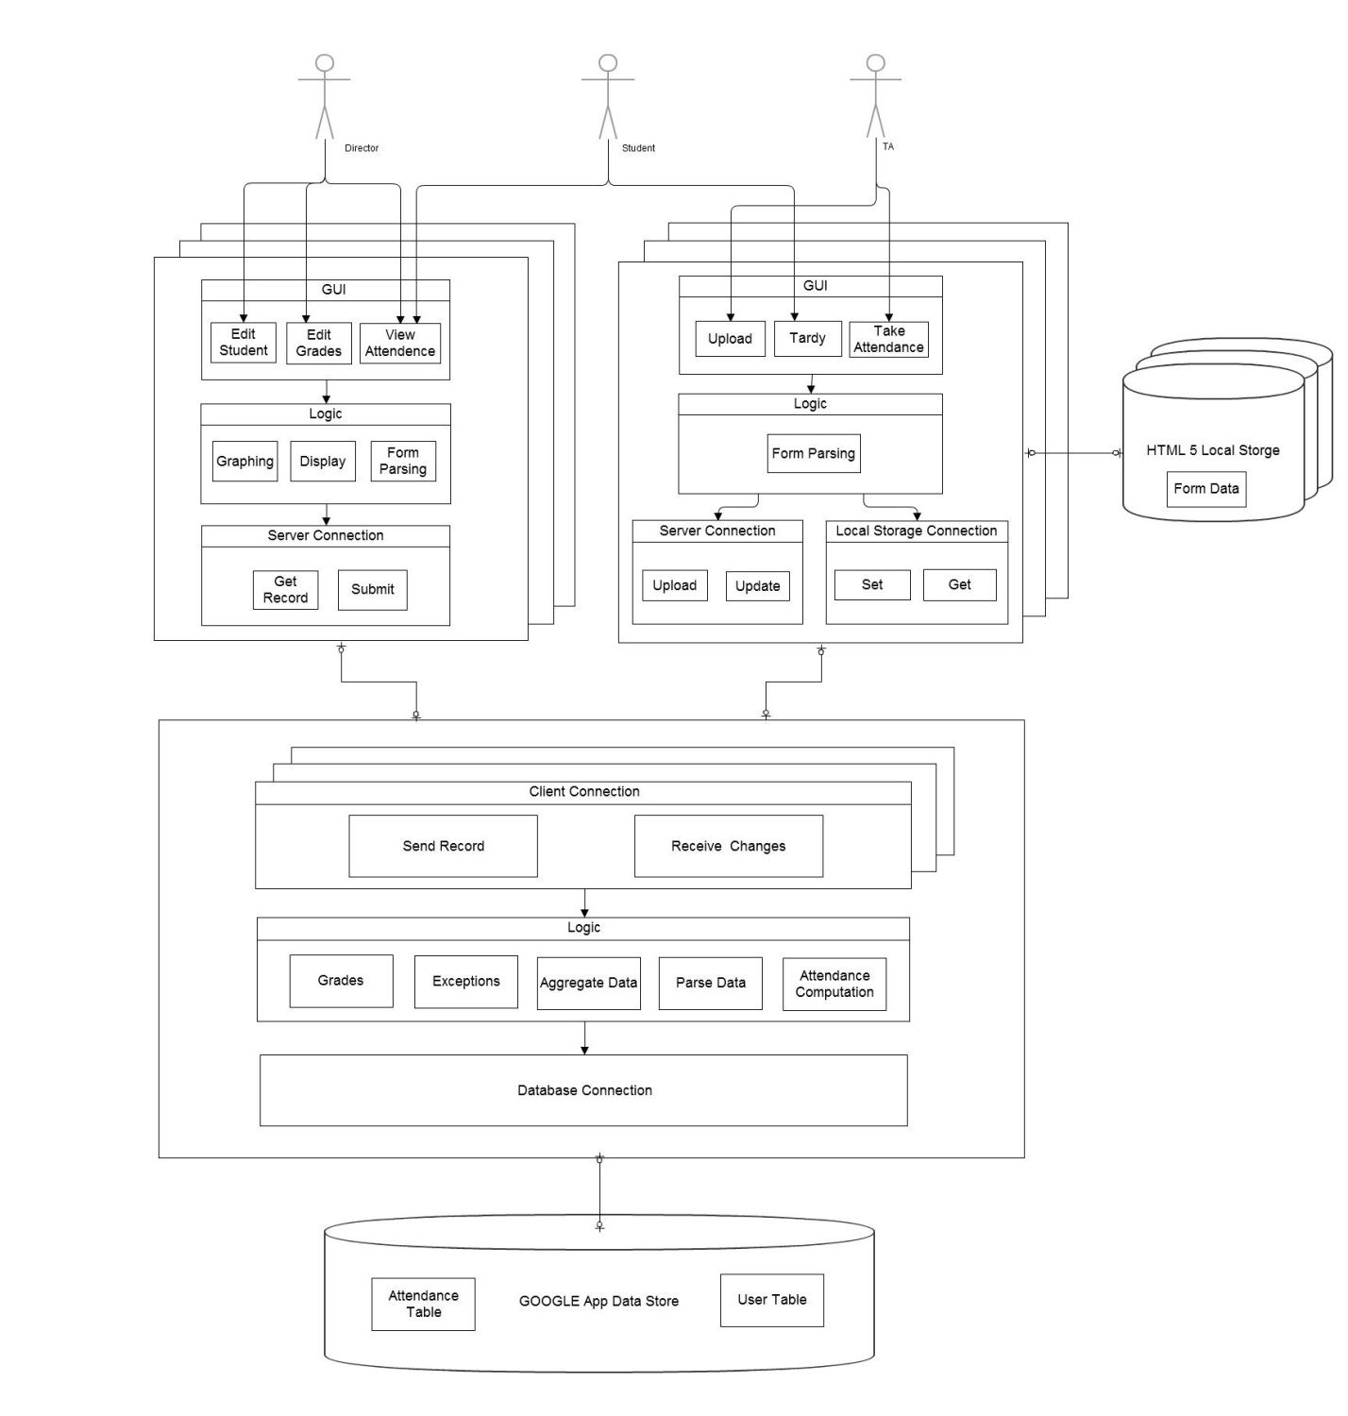

**Desktop Client**

**Mobile Client**

jdbc

http://

http://

**Server**

jdbc

Our attendance taking system will feature three types of users: TAs, directors, and students. Each of these users is represented by our diagram, though only a few of the many functions for each user have been represented for simplicity’s sake.

The system utilizes two types of clients which talk to the server, mobile clients and desktop clients. Inside the desktop client, we have a GUI component, a Logic component, and a Server Connection component. Inside the desktop client’s GUI component, the director can edit students, edit grades, and view attendance. Students can only view attendance. Other functionalities that could not be shown in the available space will be implemented. The GUI uses the logic component to make graphs of attendance data, and the logic component also parses forms into usable data.

Inside of the mobile client, we have a GUI component, a Logic component, a Local Storage Connection component, and a Server Connection component. The GUI enables the TA to take attendance and upload attendance from the local data-store. Students can submit tardies. The GUI is connected to the Logic component, which does simple data processing and is connected to the Server Connection component. This allows the user to get the record of students and submit the current attendant record from local data-store. The Local Data Store Connection allows the mobile client logic to locally store and access the current attendance data.

The mobile client and desktop client are able to send records and receive changes to and from the server via the Client Connection component. Inside of the server, the Client Connection is connected to the Logic component, which contains grade and attendance computation capabilities, handles attendance exceptions, aggregates data, and parses data. The Logic component is connected to our database. We are using Google App Engine to store data. Our database will contain two main tables: an attendance table and a user table.